**OSI Model**

Stands for **open systems interconnection** model

Was developed to make a standard way how two or more computers communicate with each other

Standard for how computers communicate with each other.

**Definition** - The Open Systems Interconnection model is a reference model from the International Organization for Standardization that "provides a common basis for the coordination of standards development for the purpose of systems interconnection."

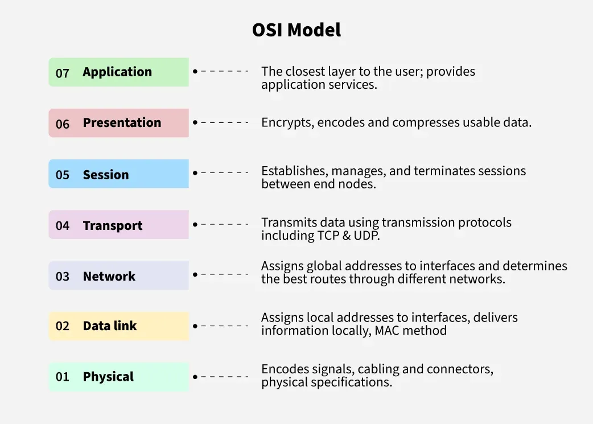

**Application layer –**

Its implemented in software

As name suggest it is in the application

You send data from application layer and now it is send to the presentation layer.

**Presentation layer –**

It takes the data from application layer and this data will be in form of what like word characters, numbers, etc. so presentation layer converts these things to machine representable binaty format

Form ASCII to EBCDIC (known as translation)

Encoding and encrypts data

Also provide extraction

Data is compressed

SSL(Secure sockets layer) protocol is used for encryption and decryption.

Then data is send to session layer.

**Session layer –**

Session layer protocol helps in setting up and managing the connection and it enables sending and receiving of data followed by termination of the connected sessions.

Establishes the session

Then data transferred to transport layer

**Transport layer –**

Transport layer

It has protocols like udp, tcp, etc.

Protocols are nothing but how data is transferred

Done in 3 parts

1. Segmentation – data received form session layer will be divided into small data units called segments.

Every segment will contain source and destinations port number and a sequence number. Sequence number helps to reassemble the segments in correct order.

1. Flow control – controls the amount of data that is being transport.

Eg. The server is sending data at 40mbps and client is receiving at 20mbps so it wont work so it will say hey slow down

Also helps in error control

Adds check sum determine the data received is good or not

Connection oriented transfer like tcp. No data is lost in tcp it gives feedback that all data is received.

And connection less oriented transfer like udp. Udp is faster coz doesn’t provide any feedback whether the data is lost or not its like whatever data u r sending just keep sending. Some data packets gets lost in upd.

**Network layer -**

**Data link layer –**

**Physical layer -**